38 38

Name:
Date:

A. $-21π$
B. $-21$
C. $-5$
D. $0$
1. Find the sum of all the negative integers $x$ satisfying the inequality $x>-2$.
B

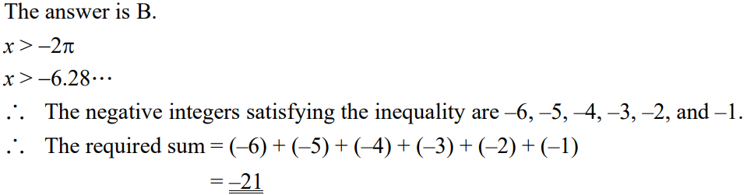

A. $4x≤2x+3$
B. $1-2x≤-2$
C. $2x+3≤6$
D. $\frac{2x}{3}≤1$
B
2. If $2x≤3$, which of the following is not true?

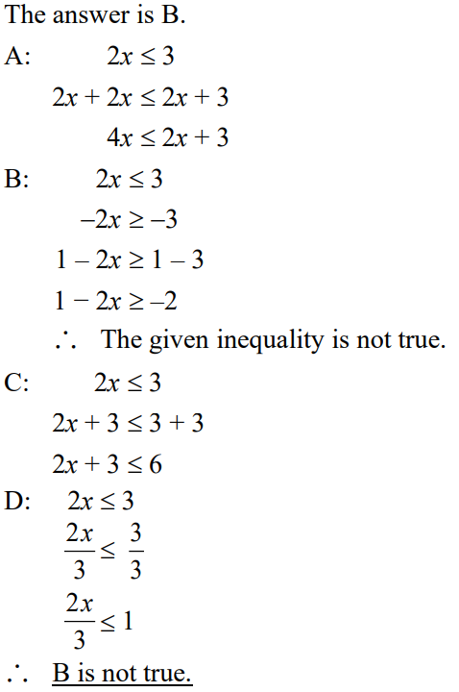



A. $x≤y<z$
B. $y-x<z-x$
C. $xz<xy$
D. $-\frac{x}{4}<-\frac{z}{4}$
D
3. If $x≤y$ and $z>y$, where $z$ is a negative number, which of the following is not true?

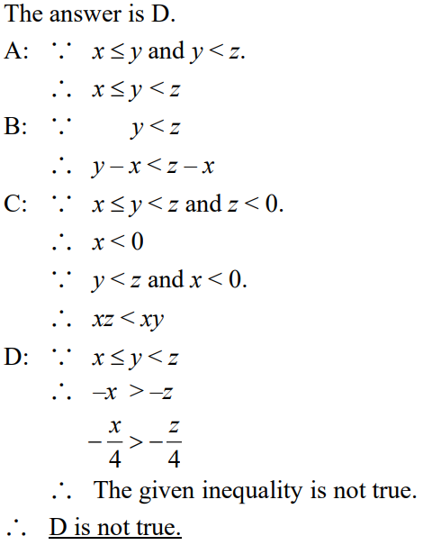



A. $x>3$
B. $x<3$
C. $x>-3$
D. $x<-3$
B
4. Solve the inequality $3\left(x+2\right)<5\left(6-x\right)$.

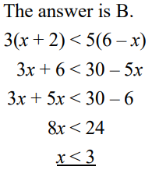

A. $-1, 0, 1$
B. $1, 3, 5$
C. $2, 3, 4$
D. $2.1, 3.2, 4.3$
D
5. Which of the following groups of numbers can all satisfy the inequality $7x+3>17$?
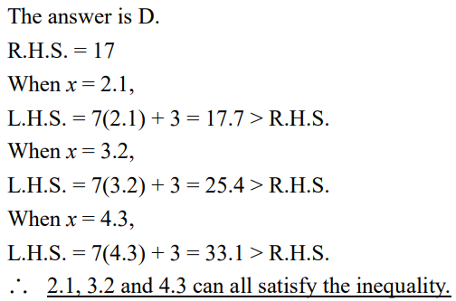

6. (a) Solve the inequality $\frac{x}{4}-2≤0.8-\frac{x}{3}$. $\left(3 marks\right)$
(b) Write down all positive integers satisfying the inequality in (a). $\left(2 marks\right)$

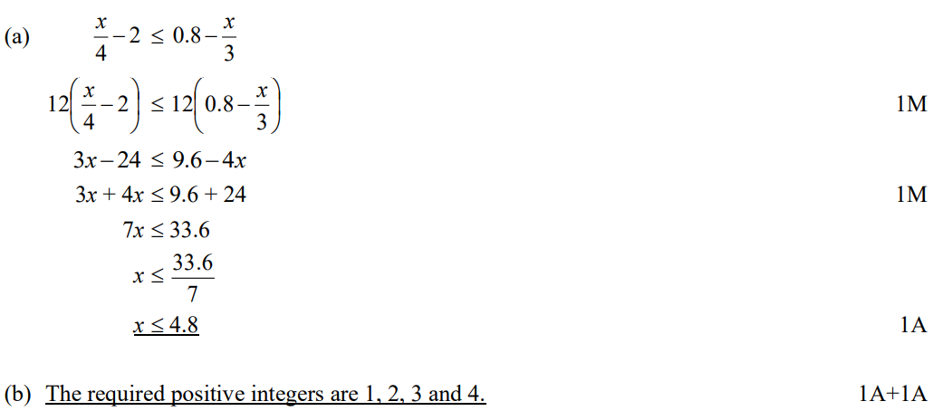

7. Write down all positive integers satisfying the inequality $\frac{4x+3}{5}<\frac{1-3x}{6}+4$. $\left(5 marks\right)$

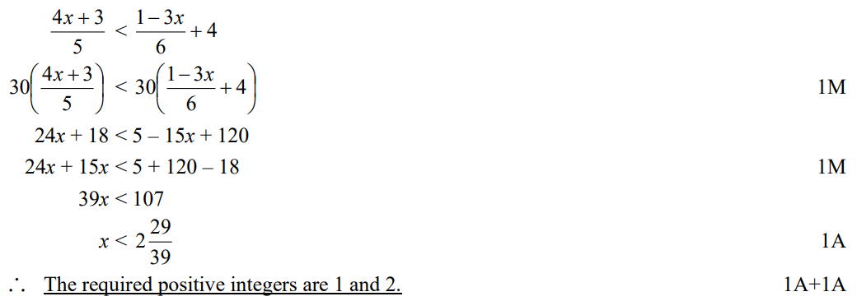

*8. A non-negative number $x$ satisfies the equation $\frac{2x-k}{3}=\frac{5x-7}{4}+\frac{x+k}{6}$, where $k$ is a positive integral constant. How many possible values of $k$ are there? $\left(8 marks\right)$

